
Insert dept name
STANDARD OPERATING PROCEDURE
Guidance for biohazardous waste management in the [name of facility/laboratory]
Insert unique SOP code/nr | Page 1 of 5

This Version
 | Name | Designation | Signature | Date
Compiled by
Reviewed by
Approved by
Effective date
Next SOP review date

1. Purpose

The purpose of this SOP is to provide the correct procedure for the segregation, disposal and storage of biohazardous waste in the laboratory facility.

2. Scope

This SOP applies to all staff and students who will be working in the laboratory. Everyone has the responsibility to read and familiarise themselves with the guidelines and safety procedures first.

3. Definitions

[Add all relevant definitions]

Biohazardous waste

Disinfectants

4. Risk management measures and risk communication

a. Personal protective equipment (PPE) required
Lab coats, gloves and closed shoes must always be worn when working with waste and/or waste containers inside the laboratory. Lab coats are kept in Room [ ]. Eye protection (goggles) must be used where there is a known or potential risk of exposure to splashes.
Dedicated biosafety level 2 (BSL-2) lab coats should be kept inside the BSL-2 lab, and only be removed from the lab to be washed. When the lab coat needs to be laundered, it must be sprayed with 70% ethanol before it is placed in a bag inside a laundry basket. The washing machine is in Room [ ].

b. Hand washing
Hands should be thoroughly lathered with [bioscrub], using friction, for at least 10 seconds, rinsed in clean water and dried using clean paper towel. An elbow-operated faucet is available at the hand-wash basins. Where not available, the paper towel should be used to turn off the faucet handles to avoid re-contaminating washed hands. Hands must be washed after removing gloves and before exiting the laboratory.

c. Signage
The signage near the waste bins indicates what types of waste are suited for the bins, drums and other containers.

5. Liquid waste treatment and disposal

Liquid waste must be decontaminated by autoclaving or chemical disinfection before disposal.

- Autoclaving: Liquid cycle at 121 °C for at least 20 minutes at 1 bar. All pathogenic waste must be autoclaved and disposed of in demarcated biohazardous waste drums. These are collected by Waste Mart for incineration. The autoclave is located in Room [ ] Autoclaved liquid waste is discarded in biohazard waste bins. Biohazard bins are stored in Room [ ] until BCL collects them. Only fill the bins to the ¾ mark. Clean bins can be found in Room [ ]
- Chemical disinfection: Prepare your own [Biocide/Bleach solution] (made fresh every day) for sterilising waste. Stock chemicals are available in Room [ ]. Biocide/bleach will be added at an equal volume to the liquid waste (in a closed plastic tube or Schott bottle), leave for an overnight kill and then dispose in the liquid biohazardous waste bin. The Schott bottles are autoclaved. In instances where tips with liquid bacterial culture waste are not chemically disinfected but contained in containers/bottles, the containers are first sterilised by autoclaving. Thereafter, the liquid waste must be decanted into the liquid waste bins in Room [ ].
- GMO-containing liquid waste: [If GMOs, GM cell lines and/or genome-edited organisms are handled in the facility, add specific instructions on the handling of waste containing these organisms or cell cultures]

BCL collects the waste on a weekly or bi-weekly basis, depending on the amount of waste generated.

Pharmaceutical waste
All hazardous pharmaceutical waste is disposed of in green pharmaceutical buckets. The waste containers must be sealed securely to ensure no spillage when handled. A complete list of the pharmaceutical content must appear on the label.
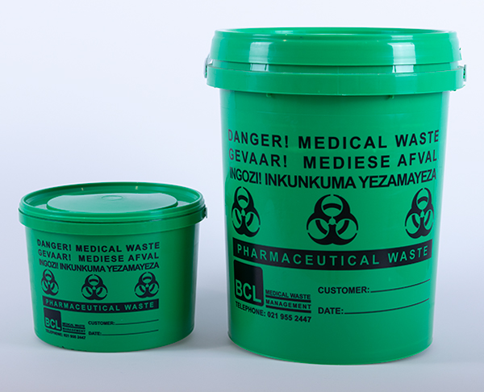

Chemical waste
[For facilities that handle chemicals, with a photograph of the chemical waste containers that are used in the facility]

6. Solid waste disposal

Red biohazardous waste bins
A red biohazardous waste bin or box lined with a biohazardous waste bag is located in each lab.
Discard the following:
Autoclaved or Biocide- treated biological cultures, including GMM cultures, gloves, small plastics e.g. Eppendorf tubes, paper towel, filter paper, Falcon tubes, Petri dishes, surgical or KN95 masks, syringes (without needles).
Please note: Do not dispose of liquid or sharps waste in these bins. Liquid and solid waste are always disposed of separately.

[Add photographs of biohazardous waste containers]

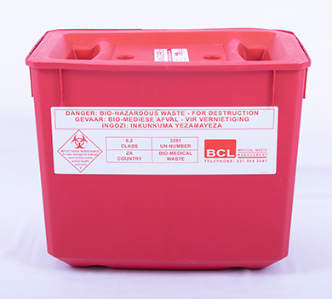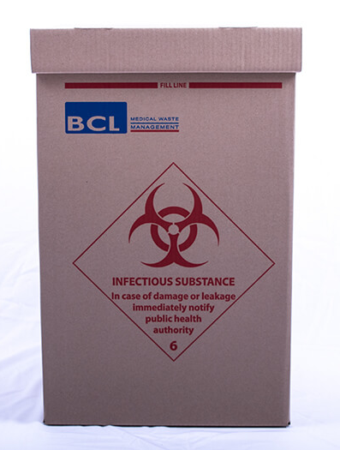

Always secure the lid on the bin. Do not leave it dangling over the box, partly exposing the contents. When your bin is ¾ full, tie up the bag with a cable tie and secure the lid. The bins should be removed weekly (or sooner, based on how quickly they are filled) and stored in Room [ ]. Ensure that the bin is correctly labelled:
Name, Department, Research lab, Date

Yellow sharps containers
Each lab has a yellow sharps waste container that is rigid, leak-proof and puncture-resistant.
Discard the following:
All sharps, including needles, scalpel blades, pipette tips and contaminated, broken small glassware. IMPORTANT: The lid of the container must be able to close. Do not fill up the container so that the lid cannot close.

[Add photographs of the sharps waste containers and the “Be smart with sharps” poster]

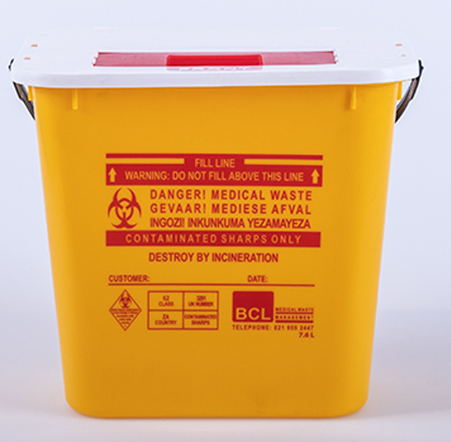

Guidelines for biohazardous waste disposal are posted on the lab, walk-in fridge and freezer doors.

Contact details of person responsible for waste management in this facility

Name
Position
Cell number (all hours)
Campus emergency number

Review of the SOP

Version History
Version number | Date | Changes | SOP amended by | Approved by

