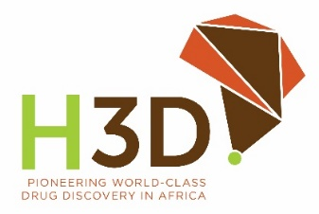
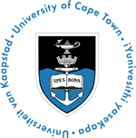

HOLISTIC DRUG DISCOVERY AND
DEVELOPMENT CENTRE (H3D)

UNIVERSITY OF CAPE TOWN (UCT)
Postdoctoral Fellowships in Medicinal Chemistry

Purpose: Post-doctoral fellowships are being offered at the University of Cape Town’s Holistic Drug Discovery and Development Centre (H3D), housed in the Department of Chemistry. The research focus for these postdoctoral fellowships will be synthetic organic chemistry and medicinal chemistry. With guidance, you will learn to use and apply data from drug metabolism and pharmacokinetics (DMPK) and biological studies to design and synthesize potential drug leads for either malaria, TB, AMR or other infectious diseases.

Why join us?
- Work at H3D, Africa’s first integrated drug discovery and development centre with state-of-the-art facilities
- Benefit from the experience at H3D, where the first clinical candidate (the antimalarial MMV048) on the African continent was developed
- Profit from internal and external mentorship programs across the different disciplines: medicinal chemistry, DMPK, enzymology, disease-focused biology, computer-aided drug discovery (CADD) and artificial intelligence & machine learning (AI/ML)
- Refine your skills in SAR studies, data analysis and compound design
- Become part of H3D’s projects, including international collaborations and gain access to a worldwide network of leading scientists from industry and academia
Call for Applications: Applicants who meet the following criteria are invited to apply for these fellowships.
- The successful applicants must have achieved a PhD degree in synthetic organic chemistry or medicinal chemistry within the past 3 years.
- Candidate must have adequate experience in multi-step organic synthesis and synthetic methodologies as evidenced by the track record of publications in reputed international journals.
- The successful applicants must be prepared to comply with the University's approved policies, procedures, and practices for the postdoctoral sector.
Conditions of Award (General): The following are the general conditions of the award:
- Postdoctoral research fellowships are only available to individuals who have achieved a doctoral degree within the past 3 years.
- Applicants must not previously have held full-time permanent professional or academic posts.
- Applicants are required to be in Cape Town at UCT for the duration of the research.
- No benefits or allowances are included in the value of the fellowship
The value of the Fellowship: R367 500 – R410 000 tax-free (depending on funding, seniority, and experience).

Period: One year, renewable as per UCT policy, contingent on satisfactory progress and the availability of funds.

Application Process:
- To apply, please e-mail the documents below addressed to Professor Kelly Chibale, Director of H3D, Department of Chemistry, in a single pdf file to Ms Chanté Foentjies (chante.foentjies@uct.ac.za).
  - A 1-page cover letter of application (stating areas of expertise, research interests, and experience)
  - A CV containing a brief summary of research work and a list of publications
  - Names and contact details of references who have taught, supervised, or worked alongside the applicant,
  - Copies of academic transcripts
The H3D Postdoctoral Recruitment sub-committee and H3D EXCO will consider eligible and complete applications. The successful applicant must ideally be available to commence with the Fellowship as soon as possible. The closing date for applications is 31st July 2026. Shortlisting will take place shortly thereafter. If applicants do not hear back from the sub-committee, kindly assume your application was unsuccessful.
Address: H3D, Department of Chemistry, Science Faculty, University of Cape Town, Private Bag X3, Rondebosch, 7700. Website: http://www.h3d.uct.ac.za

The University of Cape Town reserves the right to disqualify ineligible, incomplete, and/or inappropriate applications and the right to change the conditions of the award or to make no awards at all.

