**SKILLS DEVELOPMENT FOR CLIMATE CHANGE AND GREEN ECONOMY IN THE WESTERN CAPE**

**RESEARCH REPORT**

**Submitted**

**To**

**THE CAPE HIGHER EDUCATION CONSORTIUM**

**(CHEC)**

**BY**

**RAEL FUTERMAN**

**AND**

**CHRISPIN KAMBANI**

**August 2014**

Abbreviations and Acronyms

SAGEM South Africa Green Economy Model

WCG Western Cape Government

CHEC Cape Higher Education Consortium

UNEP United Nations Environmental Programme

UCT University of Cape Town

CPUT Cape Peninsula University of Technology

UWC University of the Western Cape

SUN Stellenbosch University

ESSP Environmental Skills Sector Plan

ILO International Labour Organisation

IEO International Employers Organisation

Table of Contents

1.0 INTRODUCTION AND BACKGROUND TO THE RESEARCH STUDY 4

1.2 The Green Economy 4

1.3 Climate Change mitigation and adaptation 5

2.0 METHODOLOGY 6

2.1 Research Delimitation 6

2.2 Research Design 6

2.3 Literature Review 7

*2.3.1 Skills supporting resource efficiency* 10

*2.3.2 Skills supporting low carbon industry* 10

*2.3.3Skills supporting climate resilience* 10

*2.3.4 Skills to manage natural assets* 10

3.0 OUTCOMES FROM UNPACKING PROVINCIAL DOCUMENTS 11

4.0 CURRICULUM MAPPING 15

5.0 IDENTIFICATION OF PROGRAMMES AND RESEARCH UNITS/CENTRES 16

5.1 Gap Analysis and Findings 16

6.0 WAY FORWARD 18

# 1.0 INTRODUCTION AND BACKGROUND TO THE RESEARCH STUDY

Western Cape Government’s vision is to become the Green Economic Hub of South Africa through the promotion of green investments and business opportunities that alleviate poverty, restore degraded ecosystems and achieve energy, water and food security. To realize this vision, the Provincial Government produced a ‘Green Economic Strategy’ that outlined a framework for the public, private and community sectors to cooperatively pursue green economic growth. This Strategy was informed by and arose from the requirements of the ‘Western Cape Climate Change Strategy’ which highlights the need for planning, preparation and innovation in order to maximize the capacity of the Province to adapt to the impacts of climate change. However, the successful implementation of the above two Strategies and response to the challenges of sustainable growth and development is dependent on the availability of specialized skills and knowledge related to the green economy and climate change mitigation and adaptation.

This report covers skills identification related to the green economy, mapping out of relevant curricula at the four universities and finally, establishing gaps, in terms of skills and knowledge and what the four universities offer.

The objectives of the research were twofold: The first was to identify gaps between industry needs and the production of specialised knowledge and skills related to the green economy and climate change mitigation and adaption, and secondly to recommend ways in which climate literacy can be incorporated into the curriculum of students in all fields; develop conceptual tools or principles that can form part of foundational courses

The definition of ‘skills’ in this educational context becomes important and ranges from practical skills to theoretical knowledge related to the field of study, and often require a combination of technical and cognitive skills. ‘Skills’ in this report, refers to this combination of knowledge, values and skills which enable an individual to do their work, in this case, those employed in ‘green’ jobs. The Dearing Report (1997) also highlighted four core skills that are key to the success of graduates in later life, regardless of their area of study. These are communication skills, numeracy, use of information technology and learning how to learn. It is important for students leaving higher education facilities to have the requisite skills and competencies necessary to meet the human resource needs of the province’s move toward a green economy. This report therefore focuses on skills and knowledge related to the green economy, referred to here as *Sustainability Literacy*

## 1.2 The Green Economy

The term ‘Green Economy’ first appeared in 1989 in the *Blueprint for a Green Economy[1]*and has given rise to various implementation strategies in countries around the globe regarding the shift to more environmentally friendly economic growth. UNEP (2011) has since defined Green Economy as one that “results in improved human well-being and social equity, while significantly reducing environmental risks and ecological scarcities.” Recently, the South African Green Economy Model (SAGEM) proposed that a green economy would stimulate economic growth in the country[2]. The Western Cape Government, with the intention to make the province central to the shift toward a Green Economy in South Africa, produced the *Climate Change Strategy and Action Plan* (2008) which outlines responses to the challenge of climate change and sustainability in the Western Cape, and more recently the *Green is Smart Western Cape Green Economy Strategy Framework* (2013) which outlines ways for the public, private and community sectors to cooperatively pursue green economic growth. In order to successfully implement the “Green Economy Strategy” and the “Climate Change Response Strategy” of the Western Cape and to respond more broadly to the challenges of sustainable growth and development, specialised knowledge and skills related to the green economy, climate change mitigation and adaptation are needed as well as higher education and college graduates in all fields who have a basic understanding of issues relating to climate change mitigation and adaptation. “Green Jobs” reduce the environmental impact of enterprises and economic sectors, ultimately to levels that are sustainable. This definition covers work in agriculture, industry, services and administration that contributes to preserving or restoring the quality of the environment” (UNEP/ILO/IOE/ITUC, 2008)

## 1.3 Climate Change mitigation and adaptation

The *Western Cape Climate Change Response Strategy (2008)* outlines two key responses toward a changing climate, *adaptation* and *mitigation*. These strategies acknowledge the dialogueous relationship between the earth’s climate and human practices. Our practices can impact negatively on the environment causing climate change, which, in turn requires a change in practice (figure1).

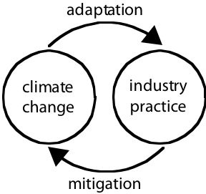

Figure 1 interconnectedness of mitigation and adaption

It defines adaptation as “the process of recognising the effects of climate change and adapting to these changed conditions”. This response requires behavioral change in line with changing climatic conditions. It often negates business-as-usual approaches to certain practices, acknowledging changing environmental conditions as determinants of future sustainable practice. Such adaptations include the development and implementation of alternative farming practices, green building standards and changes in demand-side practices. This impacts on key sectors in the Western Cape such as agriculture and energy production.

Mitigation is the reduction of the intensity of climate change effects through the reduction of greenhouse gasses and requires radical changes in energy production and consumption. A move to new ways of energy production requires new skill-sets and knowledge, similarly, reducing carbon emissions from vehicles requires new ways of thinking about transport in and around the city. Mitigation will require holistic approaches to successfully reduce carbon emissions.

# 2.0 METHODOLOGY

## 2.1 Research Delimitation

This research project is based in the Western Cape, with the aim of contributing to the province’s goal of becoming a “Green Economic Hub”. The curricula under review are based in the four universities of the province, namely the University of Cape Town (UCT), Stellenbosch University, the University of the Western Cape (UWC) and the Cape Peninsula University of technology (CPUT).

These Universities play a critical role in developing and transferring skills and knowledge through education, training and research. However, in order for the skills to be relevant, there is a need for the Universities to align their programmes and courses with the skills needs of the industry. This requires constant dialogue between universities and industry, and possibly the co-design of curricula for green jobs. The alignment between university curricula and industry requirements is imperative in streamlining the move to a green economy. This collaboration needs to be a continuous, as misalignment can lead to a) students with skills related to a green economy entering a workplace that is not ready for them, or b) a workplace in need of specific skills that students leaving university do not have. The New Growth Path (2010), aimed at enhancing economic growth, employment creation and equity in South Africa, highlighted the Green Economy as one of five priority areas for development, and set a total goal of 5 million new jobs by 2020. This can only be achieved through well-coordinated partnerships between government, labour unions, the private sector, civil society and education providers. The Green Economy Accord (2011) echoes this belief of collaboration as a fundamental enabling condition for the advancement of the Green Economy in the province.

## 2.2 Research Design

The research process (fig2) was designed around key steps in a gap analysis. The first phase involved a thorough literature review of both local and international documents related to aspects of a green economy, initially holistic, than focusing particularly on skills and knowledge requirements. Here the focus was a critical look at current practices in order to better understand the environment surrounding skills development.

This second phase of research revolved around unpacking both the *Climate Change Strategy and Action Plan for the Western Cape (2008)* and the *Western Cape Green Economy Strategy Framework (2013)* documents and conducting a literature search on the local skills required for successful implementation of green economy. These two documents framed the existing local context and the strategic goals of the Western Cape government. The third phase dealt with data collection on the four universities in the Western Cape. This involved identification of the programmes and research units/centres in the four universities related to climate change and the green economy. The assessment framework involved analyzing programmes through their faculty handbooks and online course descriptions. Finally, the researchers conducted a skills gap analysis, which looked at the relevant qualifications at undergraduate level across the universities. This analysis was done in relation to findings from the literature review and requirements in the Western Cape strategic documents.



**Figure 2. The research framework adopted**

## 2.3 Literature Review

A number of approaches have been used in undertaking this research study. Considering that Green Economy and climate change are global issues that require local actions and that countries across the world are developing initiatives to mitigate and adapt to climate change while promoting green economic development, a review of these developments was done to highlight some of the major advances both within the Western Cape and South Africa. Locally, a number of initiatives have been undertaken by the South African Government and these have also been highlighted. A number of documents were reviewed in the process. Table 1 presents key documents that informed the study with regards to identifying sectors important to transitioning to a green economy, relevant skills and knowledge, methodological approaches, benchmarking and the definition and identification of green jobs.

|  |  |  |  |  |
| --- | --- | --- | --- | --- |
| ***Green is Smart: Western Cape Green Economy Strategy Framework***  Western Cape Government  2013 | ***Green Economy Modeling Report of South Africa***  UNEP  2013 | ***A Study of the potential of promoting “Green” skills in the vocational training system of Kyrgyzstan***  HELVETAS  2013 | ***Skills for a Green Economy: Practice, Possibilities and Prospects***  RMIT University  2012 | ***Priority Skills for Biodiversity***  GreenMatter  2012 |
| ***Australian Green Skills Agreement***  TAFE Directors Australia  2012 | ***Towards a Green Economy***  UNEP  2011 | ***National Skills Accord***  Economic Development Department – RSA  2011 | ***Programmes in Support of Transitioning South Africa to a Green Economy***  DBSA  2011 | ***Skills for a Green Economy***  HM Government  2011 |
| ***Green Economy Accord***  Economic Development Department – RSA  2011 | ***Green Jobs: An Estimate of the Direct Employment Potential of a Greening South African Economy***  IDC/DBSA/TIPS  2011 | ***Skills for Green Jobs***  ILO/CEDEFOP  2011 | ***Greening the Global Economy: the skills challenge***  ILO  2011 | ***National Climate Change Response Green Paper***  Department of Environmental Affairs – RSA  2010 |
| ***Green Economy: Developing Countries Success Stories***  UNEP  2010 | ***A Human Capital Development Strategy for Biodiversity Sector 2010-2030***  SANBI/the Lewis Foundation  2010 | ***Environmental Skills Plan for South Africa***  Department of Environmental Affairs – RSA  2010 | ***Future Skills Needs of Enterprise within the Green Economy in Ireland***  Expert Group on Future Skills Needs  2010 | ***Green Jobs and Skills: the local labour market implications of addressing climate change***  OECD  2010 |
| ***Skills for Green Jobs in South Africa***  ILO  2010 | ***Future Skills Needs for the Green Economy***  CEDEFOP  2009 | ***New Skills for New Jobs: Anticipating and Matching Labour Market an Skills Needs***  European Commission: EU Communities  2009 | ***A Climate Strategy and Action Plan for the Western Cape***  Department of Environmental Affairs and Development Planning, Western Cape  2008 | ***The Economic Imperatives of Environmental Sustainability***  Department of Economic and Human Development  City of Cape Town  2007 |

Table 1: Literature Overview

According to the Green Jobs Initiative launched jointly by the International Labour Organisation (ILO), the United Nations Environmental Programme (UNEP) and the International Organisation of Employers (IOE) governments and partners, social developments can turn their potential for decent work into reality by aligning environment and employment objectives and policies. Skills development is one of the keys to unlocking this job potential.[3] The drivers of transformation to a green economy include the changes in the physical environment itself and changes induced by government regulations, more efficient technologies and changes in consumer demand.[4] This transformation caused by greening the economy affects skills needs in three ways. One is by shifting activities in the economy, for instance from less energy efficient methods that generate higher CO2 emissions towards more efficient and less polluting ones. This type of transformation occurs at industry level in what is known as green restructuring which eventually leads to decreased demand for some occupations and increase demand for others.[5] The second way in which skills needs are affected by greening the economy is through an introduction of new regulations, and the development of new technologies and practices resulting in the emergence of some entirely new occupations, although this process is very much country specific. Likewise, emerging occupations call for the provision of relevant training courses and adjustment of qualification and training systems. Thirdly, new skills will be needed by workers in many existing occupations and industries in the process of greening existing jobs.[6]

A report by the UK Government on skills for a green economy pointed out a number of specific skills needed to transform the economy into green one. Among the specifics include skills that support resource efficiency, skills that support low carbon industry, skills that support climate resilience, and finally, skills that support natural assets.[7] These seem to have been identified by the South African Government through the Country Study on Skills for green jobs[8] along with the Human Capital Development Strategy for the Environmental Sector.[9] However, it is the Environmental Sector Skills Plan for South Africa (ESSP) that provides details of the necessary skills required for the green economy in the South African Context.[10] The ESSP for South Africa identified a number of key areas of skills demand in the environmental sector, which affect the efficacy of service delivery both in public and private sector. These include leadership skills, scarce skills, critical skills, new skills for greening the economy, skills for mainstreaming the environment into development and the skills to develop and expand the sector which include environmental education and training skills. The ESSP recommends the necessity to address immediate demand and supply issues, capacity need for growing the sector in relation to green economy, building capacity and enabling innovation by ensuring adequate environmental education and training exists for developing the skills needed to respond to current gaps and future needs.[11]

### *2.3.1 Skills supporting resource efficiency*

Generally, all businesses need generic or light green skills that include strategic business management to build resource-efficient business models leading to bottom line benefits and in preparation for new regulations, business/financial accounting services around carbon and natural environment accounting, skills to design and adopt technologies, products and processes increasing resource efficiency, including lean manufacturing, project management skills with clear understanding of resource efficiency, operator level actions to maximise resource efficiency (e.g. reducing waste in production).[12]

### *2.3.2 Skills supporting low carbon industry*

In order to embark on low carbon production, industry must focus on cleaner energy generation. This requires scientists and engineers with training or transferable knowledge for nuclear and renewable energy (including wind and marine), technicians with training or transferable knowledge to install energy efficiency measures and retrofit at a household and business premises level, skills to design and adopt technologies, products and processes to minimise carbon emissions and operator level actions to minimise carbon emissions, (e.g. driving in a fuel efficient manner).[13]

### *2.3.3 Skills supporting climate resilience*

Businesses require the capacity to adapt to changes in climate and to do that they require necessary skills which should include: scientific and technical skills such as modeling and interpreting climate change projections, risk management such as assessments of future resource availability, skills to design and adopt technologies, products and processes to improve climate resilience and operator level actions to improve climate resilience, for instance retrofitting water efficient technologies in households and business premises.[14]

### *2.3.4 Skills to manage natural assets*

Natural assets underpin all business practice. Among the skills to protect and manage natural assets are, but not limited to, accounting services for the natural environment, understanding of environmental impact assessments, an understanding and interpretation of environmental legislation targets, ecosystem services design and management and land use planning, skills to design and adopt technologies, products and processes to manage natural assets.[15] This identification of skills for specific sectors provides directions as to what academic programmes would be imparting in the university institutions and Technical vocation Training schools in Western Cape.

# 3.0 OUTCOMES FROM UNPACKING PROVINCIAL DOCUMENTS

This phase of research revolved around unpacking both the *Climate Change Strategy and Action Plan for the Western Cape (2008)* and the *Western Cape Green Economy Strategy Framework (2013)* documents. The WC Green Economy Strategy Framework (2013) identifies five key drivers linked to making the Western Cape the leading green economic hub in Africa. These drivers are *Smart Living and Working, Smart Mobility, Smart Ecosystems, Smart agri-production* and *Smart Enterprise.*They list five enablers of these sectors, these are*Finance, Rules and Regulation, Knowledge Management, Capabilities* and *Infrastructure.* Research began with the interrogation of this matrix where the enablers for each of the drivers were unpacked into three focus areas, *requirements, challenges and opportunities* (Appendix C). These focus areas provided us with possible key areas for curriculum development regarding the shift to a green economy. These *requirements, challenges* and *opportunities* can also be seen as the skills and knowledge required by industry’s shift to a green economy, and informed the scarce and critical skills component of this study, along with the literature review.

The Drivers and Enablers matrix in the *Western Cape Green Economy Strategy Framework* (2013) was edited in order to explicate which industries could contribute most to the green economy. This unpacking facilitated the outline of learning pathways appropriate to the industries. Figure3shows the drivers split from their specific pillars and instead regrouped into three levels of enablers, namely *Industry, Occupations (within these Industries),* and *Enabling Skills* that cut across all occupations. This matrix formed the basis for further investigation into skills and knowledge important for the shift to a green economy.

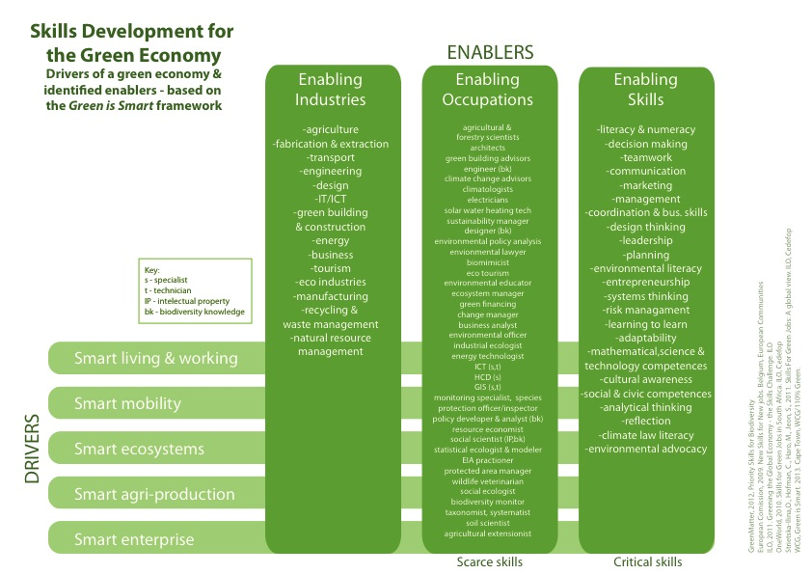

Figure 3 drivers split from their specific pillars and instead regrouped into three levels of enablers, namely Industry, Occupations and Enabling Skills

Figure 4shows a regrouping of the above matrix and the division of critical cross-cutting skills into the three areas of *technical, organizational* and *personal.*

These skills are integral in the education of students in fields that could contribute to the shift to a green economy. Although termed critical skills here, this list also includes knowledge and abilities. This blend of knowledge, skills and abilities is critical in forming the basis for further learning and practice in green economy related industries. Although the focus is on University curricula, these skills are also appropriate to lifelong learning and the reskilling of existing workforces whose industries will begin to shift focus as they move to more sustainable practices, such as the shift from brown to green energy production. Each occupation also has its own set of skills, knowledge and abilities requirements, and each industry has certain overlapping knowledge fields important for communicating with other occupations within that sector. These occupations and industries were regrouped into certain key sectors, and formed the new set of drivers for the green economy.

Figure 6 presents the sector-linked drivers and enablers matrix used in identifying relevant curricula at the four universities in the Western Cape.

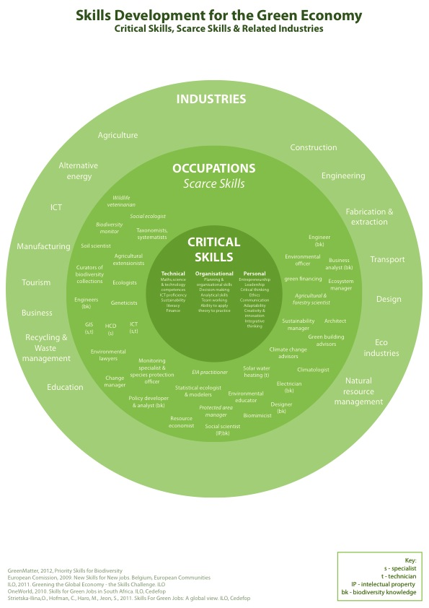

**Figure 4 regrouping of the above matrix and the division of critical cross-cutting skills into the three areas of technical, organizational and personal.**



Figure 5: Critical Cross cutting skills

This adapted matrix lists *Renewable Energy, Natural Resource Management (including Agri/mariculture), Tourism* and *Transport and Communication* as the key sectors related to the green economy in the Western Cape. These Drivers are enabled by *Financial and Legal Services, Digital and Physical Infrastructure,* and *Multimodality*. Multimodality in this case refers to the different ways in which each driver can be realized through design and engineering. For example, in Renewable Energy, multimodality would refer to the modes of energy production such as solar voltaic, wind and tidal etc.

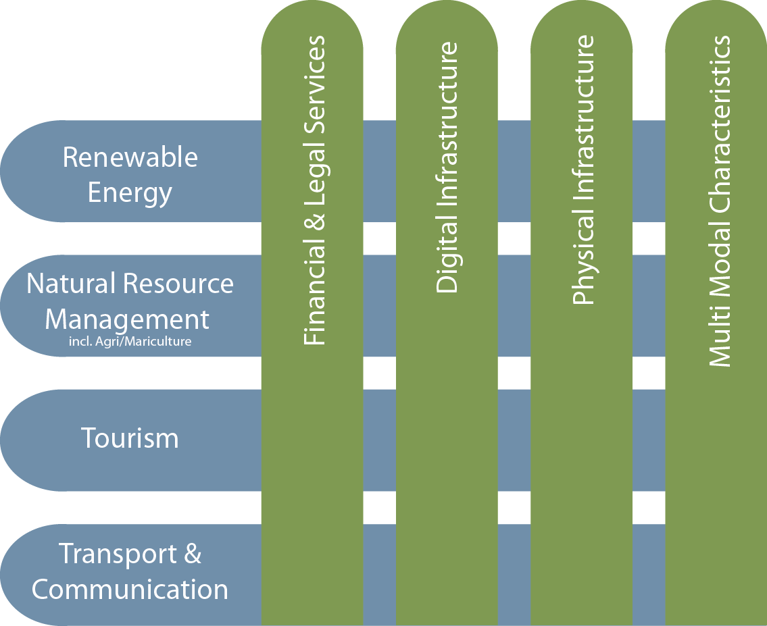

Figure 6 Sector-linked drivers and enablers matrix used in identifying relevant curricula at the four universities in the Western Cape

# 4.0 CURRICULUM MAPPING

The relevant university programmes were mapped out with industries and occupations in mind, using university websites & faculty handbooks. Appendix A provides the detailed findings on the programmes offered across the four universities.

The Curriculum mapping exercise involved a thorough analysis of each programme, at the four Western Cape universities that prepares students in areas related to the green economy. The 4 focus areas were *Transport and Communication, Natural Resource Management (incl Agri/Mariculture), Tourism* and *Renewable Energy.* This exercise provided insight into the following:

* alignment of programmes with the needs of industries related to the Green Economy
* alignment between similar courses across the universities
* gaps in education related to the green economy
* opportunities for GE component inclusion in the various curricula
* skills and knowledge in related programmes
* relevant modules for discussion
* similarities/differences in similar programmes across the universities, with regard to content, structure and naming

# 5.0 IDENTIFICATION OF PROGRAMMES AND RESEARCH UNITS/CENTRES

Certain research entities (Units, Centres and Institutes) were also identified, although most of these offer specialist training at a postgraduate level. Some also offer certificates and diplomas in green economy related fields. (Appendix B) shows a general overview of research entities across the four universities that offer green economy related research and trainings both to undergraduates and postgraduate students

## 5.1 Gap Analysis and Findings

The mapping of university curricula related to the Western Cape’s move toward a green economy presented a few interesting points for discussion. Key points are as follows:

* Certain courses such as engineering and IT, both imperative for the green economy, have a generic first year. This foundation year could be a good place to introduce sustainability and climate change literacy to all students in the programme.
* In some instances, certain programmes important to the green economy are only offered at one of the four universities. It would be interesting to discuss with industry if there are skill shortages in these fields, and if so, how capacity could be built to support these programmes.
* Environmental Engineering is not offered at any of the universities
* Universities have similar courses that are named differently – this could impact on students entering the workplace.

**5.2 Examples of Modes of Best Practice**

* *Modules in Undergraduate Programmes:*

The Department of Environmental and Geographical Sciences (EGS) at the University of Cape Town (UCT) offers an undergraduate course delivered through a team-teaching model by three human geographers. The course, EGS1003S*Geography, Development & Environment* is a component of the first-year curriculum for students in the Faculty of Science amongst others. The course introduces students to development and environment debates in geography, by exploring the geography of third world development, focusing on the historical roots and spatial patterns that underpin development. The team-teaching model allows lecturers to take unique approaches toward achieving learning goals including a variety of content related to development and the environment in the sub-discipline of human geography. In recent years, one section of the course focuses on climate justice, and the differing adaptive capacities of communities and individuals around the world varying across scales of ‘development’. Although the course does not specifically focus on climate change, the content is critical in building skills and awareness of climate-related issues. Rather than developing new curricular requirements across faculties, the team-teaching model as effected through EGS1003S allows students to acquire basic knowledge that informs transition to a green economy.

* *Interdisciplinary/ Interdepartmental Research activities:*  The Minerals to Metals initiative at the University of Cape Town (UCT) whose aim is to “…integrate and expand capacity in minerals beneficiation research by drawing together the skills of world-renowned academic and research staff within four research groupings in the Department of Chemical Engineering, the Department of Physics, the Positron Emission Particle Tracking (PEPT) Research Group, and the Centre for Research in Computational and Applied Mechanics (CERECAM)” was formed to combine research knowledge and capacity from multiple, linked disciplines in the area of materials beneficiation. As climate change and the green economy requires interdisciplinary approaches, other departments could look at linking components of their programmes to develop specific modules related to skills required in their field and related to the green economy, e.g. *Natural Resource Management* and *Agriculture*, to research sustainable methods of ensuring food security; *Architecture* and *Engineering* (mechanical, chemical and electrical) to research ways in which buildings could produce their own energy as per their requirements.

The National Post Graduate Qualifications in Renewable Energy programme is a proposed mix of postgraduate diplomas and Masters degrees with a focus on Renewable Energy. This initiative is currently supported by: the Centre for Renewable and Sustainable Energy Studies, Stellenbosch University; the Centre for Energy Research, Nelson Mandela Metropolitan University; Fort Hare Institute of Technology, University of Fort Hare; the Department of Physics, University of Limpopo; and the Energy Research Centre, University of Cape Town. These universities would collaborate by (a) sharing the presenting/lecturing of the postgraduate course modules, and (b) study leading of research projects/theses where required. Modules would be shared across universities, with students and lecturers moving between institutions.[16]

* *Dedicated Research Units*  The South African Renewable Energy Centre (SARETEC) at CPUT acknowledges the shift in energy production, to more sustainable methods, as important in the move to a greener economy. This research and training centre is focused on training graduates in Renewable Energy production, a key area related to Skills Development for the Green Economy.

# 6.0 WAY FORWARD

During the validation phase of this report a workshop with the four Western Cape universities was arranged where the universities commented on the report findings, shared case studies and presented best practices.

The workshop included representatives from a range of faculties across the universities and focused on the renewable energy pillar of the green economy.

During the workshop, some ideas were put forward regarding the inclusion of green economy related content in university programmes, these were:

* Embedding related green economy aspects into existing courses, rather than designing new modules.
* Courses that use case studies in their first year could refocus these to include green economy related topics.
* Development of bridging courses where two or more departments feed into each other.
* Investigation into open learning approaches to reduce crowded curricula
* Identification within universities of new fields of study, such as nanotechnology, for new programme development.
* Exposure of university programmes related to green economy, possibly on university websites, in order to garner interest and facilitate linkages between universities.

It was also agreed that the province would facilitate a discussion between the universities and industry. It was suggested that this take the form of a symposium where universities and business could present and share information related to green economy successes and challenges.

**References**

1. CEDEFOP, ‘Green Skills and Environmental awareness in vocational education and training’, *Synthesis Report*, *Vol.130*, (2012), European Centre for the Development of Vocational Training, [www.cedefop.europa.eu/EN/Files/5524_en.pdf](http://www.cedefop.europa.eu/EN/Files/5524_en.pdf).
2. CEDEFOP,( 2011) Skills for Green Jobs, *A Global View,* Synthesis Report Based on 21 Country Studies, ILO.
3. European Commission (2008), New Skills for New Jobs, *Anticipating and Matching labour market and skills needs,*
4. HM Government (2011), Enabling the Transition to a Green Economy: Government and Business Working together.
5. Western Cape Government (2013), Western Cape Green Economy Strategy Framework: *Green is Smart*.
6. Department of Environmental Affairs, *A climate change strategy and action plan for the Western Cape,* December 2008, Final Report
7. Lochner, P. 2005. Guideline for Environmental Management Plans. CSIR Report No ENV-S-C 2005-053 H. Republic of South Africa, Provincial Government of the Western Cape, Department of Environmental Affairs & Development Planning, Cape TownCEDEFOP, (2009), Future skill needs for the green economy, European Centre for the Development of Vocational Training.
8. Skills for green jobs in South Africa, Unedited background country study,  *World Sustainable Investments (OneWorld)* , ILO Skills and Employability Department, 2010
9. Lochner, P. 2005. *Guideline for Environmental Management Plans*. CSIR Report No ENV-S-C2005-053 H. Republic of South Africa, Provincial Government of the Western Cape, Department, of Environmental Affairs & Development Planning, Cape Town.
10. Department of Environmental Affairs ( 2010),  *Environmental Sector Skills Plan for South Africa: A systems Approach to Human Capacity Development and Sector Skills Planning*

|  |  |  |  |  |  |  |  |  |
| --- | --- | --- | --- | --- | --- | --- | --- | --- |
| Appendix A  **Key competences required, relevant programmes/modules offers and potential gaps across the four WC Universities**  **\* Programmes/modules being recommended by researchers based on the core competences identified. These programmes/modules aren’t currently offered at any universities in the Western Cape** | | | | | | | | |
| **Driver** | **Required Knowledge and core competencies** | | **Related Programmes /Modules across universities** | | | | | **Potential gaps and research findings** |
| Knowledge  *Theoretical or practical understanding of a subject* | Skills  *Proficiencies developed through training or experience* | Programmes (P)  Modules (M) | CPUT | UWC | UCT | SUN |  |
| **Transport &**  **Communication**  The relevant industries associated with this driver are many as this is key economic sector that enables all other economic sectors. | Road construction.  Environmental impact of engineering developments.  Engineering Development, planning, metals and materials, Renewable construction,  Advanced building management systems,  Transport/road networks Telecommunications,  Renewable construction,  Sustainability  Compliance and enforcement,  Information technology applications and development | Road design engineers, mechanic and electrical engineers, streets, railways construction engineer, canals-irrigation systems engineers,  Electrification infrastructure, technicians, maintenance technicians.  Design, manufacturing and management skills, traffic control systems analysts  Computer experts  Communication skills  Environmental Leadership skills  Public transport systems  Town and City Planning  Sustainability  Compliance and Inspection skills | 1. Civil Engineering (P) 2. Electrical and Electronics Engineering ( P) 3. Mechanical Engineering ( P) 4. Chemical Engineering (P) 5. Property Management (P) 6. Information, Communication Technology(P) 7. Telecommunication ( P) 8. Physical Planning and Land Management (M - Surveying) 9. Construction Studies (P) 10. Industrial and Systems Engineering (P) 11. Computer Systems (P) 12. Information Technology (P) 13. Geomatics (P) (M-Surveying CPUT) 14. Geoinformatics (P) 15. Industrial Design (P) 16. Graphic Design (P) 17. Computer Sciences 18. Environmental Management (P) 19. Urban Ecology (M) | √  √  √  √  √  √  √  √  √  √  √  √  √  √  X  √  √  √  √  X | X  X  X  X  X  X  X  X  X  X  X  X  X  X  X  X  X  √  X  X | √  √  √  √  √  √  √  √  X  X  √  √  √  X  X  X  √  √  √ | √  √  √  √  √  √  √  √  X  X  X  X  X  √  X  X  √  √  X | Engineering programmes are offered at all universities except UWC, from National Diploma (NDip-CPUT) to Postgraduate Degrees. Some of the degree programmes are named differently by different universities, for example Construction studies and Property studies (UCT) but Construction Management at CPUT. Transportation Engineering and Transport Planning and Technology are offered as modules in a Civil Engineering Diploma and Degree respectively at CPUT. This also includes Environmental Engineering as a module in Mechanical Engineering and Urban Planning and Design, which are offered as subjects at CPUT within the Engineering department.  In terms of research in transport and communication, the Institute for Integrated Transport Technology at SUN does research and training while the Centre for Transport Studies (UCT) and African Centre for Cities (UCT) offers postgraduate qualifications in the field of urban passenger transport planning and management and applied research in urban problems and challenges.  So far, no university offers Environmental Education and Training as a programme. UCT’s undergraduate Civil Engineering programme does however include an introductory session on concepts of sustainability/climate change at first year level, and again at 3rd and 4th year affiliated courses. Opportunities also exist at both 4th year and post-graduate level to be involved with sustainability research In specific research projects.  UCT also has a focus in its Information Systems Department on Green Information Systems (Green IS). This is done through live projects focusing on measuring and mitigating UCT’s carbon footprint and incorporated into the third year IT Management course. Other faculties also contribute, these include: Science, Commerce, and Engineering. |
|  |  |  |  |  |  |  |  |  |
| **Agriculture, Natural Resources and Biodiversity Management**  The relevant industries associated with this driver include: supermarkets, wine industry, fishing industries, pharmaceutical industry, Tourism Industry,  Consumer Associations,  Environmental NGOs,  Civil Society Organisations,  Research Institutions, | Food Security  Food Regulations and policies.  Land management  Conservation agriculture,  Ecosystems management,  Smart agriculture  Sustainable agriculture  Agricultural Policies  Marketing and logistics  Conservation education, urban and peri- urban agriculture  Sustainable farming practices.  Wildlife Conservation,  Biology and Ecology  International Instruments  National laws regarding environment. | Sustainable fishing skills, climate smart agriculture extensionists , conservation agriculture and ecosystems management specialists, irrigation engineers, Environmental and natural resources law experts, Soil and Water Resources management specialists, Disaster Risk Managers, Agribusiness management experts, Biodiversity Scientist, Forest Experts, Marine Biologist, aquaculture and Mari-culture experts, Fisheries Scientists, Environmental and resource economists, Agricultural Economists, Crop and soil scientist, Botanists, Horticulturalist, Wine farming experts  Agronomists  Sustainable harvesting skills  Environmental Management experts. | 1. Agricultural Production systems (P) 2. Agronomy (P) 3. Oceanography (P) 4. Aquaculture (P) 5. Forestry and Natural Resources Sciences (P) 6. Environmental Law and Policy ( P) 7. *Agricultural Policy*\* 8. Soil and Water Conservation (p) 9. *Conservation Agriculture\** 10. *Climate Smart Agriculture*\* 11. Agricultural Economics and Management (P) 12. Agricultural Business Management (P) 13. *Agricultural Irrigation*\* 14. Wine farming(P) 15. *Ecosystems Management*\* 16. Integrated Water Resources Management (P) 17. *Urban Agriculture*\* 18. *Disaster Risk Management*\* 19. Biodiversity Conservation 20. *Mari-culture*\* 21. *Agricultural Extension*\* 22. Project Management (P) 23. Fisheries Resource Management (P) 24. Adapting to Global Change (M) 25. Water Resource Management (M) 26. Environmental Policy and Practice (M) 27. Environmental Economics (M) 28. Climate Change Adaptation and Mitigation (M) 29. Environmental Management (M) 30. Managing Complex Social-Ecological Systems (M) 31. Climate Change and Predictability (M) 32. Sustainable Urban Systems (M) 33. Biodiversity and Climate Change (M) 34. Climate Law and Governance (M) | Y  Y  √  X  √  X  X  √  X  X  √  X  X  X  X  X  X  X  X  √  X  X  √  √  X  X  X  X  X  X  X  X  X  X  X | X  X  X  X  X  √  X  Y  X  X  X  X  X  X  X  X  √  X  X  √  X  X  √  X  X  X  X  X  X  X  X  X  X  X  X | X  X  √  X  X  √  X  X  X  X  X  X  X  X  X  X  √  X  X  √  X  X  √  √  √  √  √  √  √  √  √  √  √  √  √ | √  √  √  X  √  √  X  X  X  X  √  √  X  √  X  X  √  X  X  √  X  X  √  √  X  X  X  X  X  X  X  X  X  X  X | Diplomas and Degrees in Agricultural related programmes are offered at SUN and CPUT only. CPUT offers National Diplomas in addition to Degrees and Higher degrees while SUN offers Degrees and higher degrees. However, almost all the universities offer either degrees/ diplomas and in some cases offered as modules and courses. However, Climate Smart Agriculture, Conservation Agriculture, Ecosystems Management are some of the new courses that contribute to smart agriculture. Yet they are not been offered. Disaster risk management, Mari-culture, Agriculture irrigation are also missing from the programmes. As is the case with the first driver discussed above, some relevant modules and courses are offered within programmes.  It should be noted that agriculture, nature and biodiversity conservation require technical expertise at the lower level. The fact that National Diploma is only offered at one University, gives a picture that there are fewer technicians in this very important sector.  Although UWC offer nature and biodiversity resources related programmes, it is important that agriculture starts being offered as well because these cannot be isolated. This will enhance efforts of adapting to climate change in terms of creating more knowledge and expertise on climate smart agriculture.  The Department of Tourism Management at CPUT deals extensively with the impacts of tourism from a sustainability perspective and a responsible tourism management perspective.  The former relates more to policy and planning while the latter relates more to the day to day management of tourism in a responsible manner, i.e.  to reduce negative triple-bottom-line/people-planet-profit/economic-social-environmental impacts and enhance positive impacts.  The focus is therefore not just on environmental issues, but certainly includes it.  These topics are covered in the Tourism Management and Tourism Development subject areas.  The focus is not to train our students as environmental scientists, but to sensitize them to environmental issues related to tourism management and development as possible future entrepreneurs, tourism authority or tourism business employees.  UCT offers a number of honours and master modules related to this sector, as can be seen from no. 24 - 34 |
| **Renewable Energy**  Skills for renewable energy cut across the value chain that starts from equipment manufacturing and distribution, project development, construction and installation, operation and maintenance, biomass production as well as cross-cutting occupations. These relate to Wind, solar, hydropower, Geothermal, and Bioenergy.  The building industry, Power and Energy , settlements Government and many others require sustainable energy supply | Green buildings  Energy efficiency  Energy regulations and policy,  Engineering materials  Construction engineering and management  Urban Planning and building regulations  Sustainable settlements  Transport systems  Sustainable urban landscape design  Marketing  Laws and Regulations  Standards and Compliance and enforcement issues | Information and communication technologists,  Software and systems development skills, Waste Recycling, Reuse and management, Civil Engineers, Electrical and environmental, mechanical and wind power designers( engineers), architects, project designers, Atmospheric scientists, Industrial mechanics, Resource assessment specialists,  Plant managers, measurement and control engineers, Business developers, commissioning engineers, Agricultural scientists, biomass production managers, Procurement professionals, logistics professions, manufacturing quality assurance specialists, industrial mechanics Certifiers, manufacturing engineers, environmental lawyers-consultants,  Environmental education, Solar systems designers, | 1. Civil Engineering (P) 2. Electrical and Electronics Engineering (P) 3. Mechanical Engineering (p) 4. Chemical Engineering ( P) 5. Construction Studies (P) 6. Information, Communication Technology (P) 7. Telecommunications (P) 8. Physical Planning and Land Management (P) 9. Construction Management (P) 10. Industrial and Systems Engineering, (P) 11. Computer Engineering (P) 12. Atmospheric Science ( M) 13. Urban and City Planning(M) 14. Information Communication and Technology( P) 15. Energy and Climate Change (M) 16. New and Renewable Technologies (M) | √  √  √  √  √  √  √  √  √  √  √  √  √  X  √  √  X  X | X  X  X  X  X  X  X  X  X  X  X  X  X  X  X  √  X  X | √  √  √  √  X  √  √  √  √  X  √  √  √  √  √  √  √  √ | √  √  √  √  X  √  √  √  √  X  √  √  X  √  √  √  X  X | Like in Transport and communication, Engineering programmes in the Universities are central in providing the necessary skills in establishing a sound renewable energy programmes. This involves a value chain of products from production to installation and maintenance across a number of renewable energy enablers like wind, solar, hydropower, geothermal and bioenergy.  Hence the need for diverse array of skills from all the engineering programmes and natural science.  Scanning across the programmes relevant to producing the necessary skills across the universities, similar observations are made when some areas are cover as degree programmes while others as just modules within a degree programme and again some important skills can only be gained at postgraduate level as they would require acquisition of some basic knowledge at undergraduate level. For example Climate Change and Sustainable Development, green buildings and energy efficiency among others. Most important however for the renewable energy is a colossal of research based institutes and centers across the universities focusing on renewable energy. Renewable energy technologies require advance knowledge and skills that can only be acquired at higher level and not foundation level as this study is about. |
| **Tourism** | Managing ecotourism business,  Ecosystem goods and services, sustainable harvesting methods for flora and fauna,  Waste Management  Waste recycling and reuse, Green technologies, Nature Conservation  Urban and City Planning issues  Climate change adaptation and mitigation | Environmental management experts,  Biologists, ecotourism specialists, Nature conservation experts, ecologists, sustainable management systems specialists, travel and hospitality management skills, language skills, guiding and interpretations, NRM skills, Outdoor recreation skills, community based ecotourism, sustainable development skills  Marketing skills, Environmental Policy  Wildlife Management skills | 1. Nature Conservation (P) 2. Environmental Policy (M) 3. Environmental Management( P) 4. Tourism management (M) 5. *Ecotourism\** 6. Hospitality Management 7. Ecology/Biodiversity Management (P) 8. Marketing(M) 9. Entrepreneurship (M) 10. Business management (P) 11. Environmental sustainability(M) 12. *Wildlife management\** 13. *Coastal Zone Management\** 14. Travel and Tourism (P) 15. Business Communication (P) 16. Climate Change Science(M) 17. Agricultural Economics (P) 18. Agronomy(P-SUN) 19. Natural Resource Economics(P) 20. Environmental and Geographical Sciences (P) 21. Geographical Information Systems(M) | √  √  √  √  X  √  √  X  √  √  √  √  X  X  √  √  √  √  X  X  X  X | √  √  X  X  X  √  X  √  x  √  X  √  X  X  X  X  X  X  X  X  X  X | √  √  √  √  X  √  √  X  √  √  √  √  X  X  √  √  X  X  X  X  √  √ | √  √  √  X  X  X  √  X  √  √  √  √  X  X  X  X  X  √  √  √  √  √ | There are no programmes/modules on Coastal Zone Management at any university but some of the modules and programmes offered do tackle issues related to the same. Like UCT has a module in Ecosystem Ecology ( (Applied Biology/ Marine Ecology), Earth and Physical Environment (EGS). In other cases short courses are offered like UCT offer tourism management and event management as short courses, inaddition to offering it as a module.  Responsible Tourism, requires skills and knowledge in Eco-tourism as this will enhance sustainable tourism and promote a culture which enhances sustainable use of resources. Ecotourism encourages community participation because they gain direct cash benefits through a display of some cultural dances.  Names of the programmes or modules may differ across the universities. |

Based on the drivers and skills identified through the relevant national documents and literature on green economy and climate change related, a number of degree programmes have been isolated from the four universities most recent booklets and websites. It has been noted that while some programmes (degree) are available in all the universities, others are only available in one or two of the four. For example agricultural related programmes are available at Stellenbosch University and Cape Peninsula University while University of the Western Cape does not offer any Engineering related programme. The table further shows some programmes (in asterix) which have been suggested based on the identified core competences. The list of programmes is not exhaustive as some which are not listed may still be important.

**Appendix B Research Centres and Units across the universities that can offer further knowledge and skills relevant to Green Economy and Climate change**

Apart from the Diploma and Degree programmes, Universities also conduct research in various fields related to green economy, climate change as well as offer postgraduate training ranging from Postgraduate Diploma to PhDs. The table below shows some of the research centres and units across the universities.

|  |  |  |
| --- | --- | --- |
| **CENTRE/INSTITUTE** | **AREAS OF RESEARCH** | **UNIVERSITY** |
| Institute of Marine and Environment Law | The institute monitors development in the law of the sea and environmental law both the national and international level and in the southern Africa context. Also provides training and postgraduate research in the following areas Environmental law, Climate Change Law, Marine Law among others. | UCT |
| Environmental Evaluation Unit | The Unit conducts research and short courses in the following areas Coastal and Fisheries Governance, Biodiversity and Social justice, Business and Sustainability, Environmental management and sustainability and Environmental Governance. | UCT |
| Urban Water Management Research Unit (UWM) | The UWM is an accredited, interdisciplinary research unit. Its main aim is the providing integrated and sustainable approaches to addressing problems of water management in the urban areas of Southern Africa.The unit comprises of members, both lecturers and students, from the following departments: Dept of Architecture, Planning and Geomatics; Dept of Civil Engineering; Dept of Construction Economics & Management; Dept of Environmental & Geographical Science; Department of Political Studies; and the School of African and Gender Studies, Anthropology and Linguistics. | UCT |
| Climate Systems Analysis Unit | CSAG is a unique research group within Africa with an eclectic mix of specialties, but most importantly put the needs of developing nation users at the forefront of everything it does. As a result, CSAG seeks to apply the core research to meet the knowledge needs of responding to climate variability and change. | UCT |
| African Centre for Cities | ACC serves as a platform for interdisciplinary research on urban issues - like ways of knowing urban ecologies, urban food security, Cape Town Local Interaction Platform, as well as urban infrastructure and design. The primary focus is on applied research to address complex, intractable urban problems and challenges. | UCT |
| Energy Research Centre | Energy and Climate Change, Energy Poverty and Development, Energy Efficiency, Energy modelling. | UCT |
| Centre for Bioprocess Engineering Research | The Unit maintains a productive balance between research centred on the application of biological principles through process development and on the fundamental understanding of biological processes at the mechanistic level and of the interaction of these processes with their environment. | UCT |
| Centre for Research in Engineering education | Aims to promote and develop research in engineering education that informs the development of the learning environment and the educational process, in order to improve student learning. | UCT |
| UWC Nature Reserve | The UWC Nature Reserve functions as an independent Unit within the faculty. UWC Nature Reserve is fast establishing itself as a force to be reckoned with in the fields of environmental education, indigenous greening and nature conservation. (Cape Flats Nature Reserve, Environmental education, and community involvement). | UWC |
| Institute of Water Studies | Promotes research and training on water-related issues through collaborative efforts of UWC staff. Aims to increase understanding of surface water, ground water, and ecosystems linkages and how water users are affected and affect the linkages. | UWC |
| Sout African Institute for Advanced Materials Chemistry | SAIAMC is an internationally recognised innovationhub in the strategic focus area of Energy. SAIAMC has demonstrated the development and operation of a full scale Li-ion battery, Fuel Cell Membrane Electrode Assemblies- and Hydrogen Metal Hydride- pilot-plant manufacturing facilities at UWC and leads the development of low cost large scale energy storage materials and systems, the missing link for the full scale implementation of power generation from intermittent resources. SAIAMC is the host for HySA (Hydrogen South Africa) systems that focus on the (i) developmetn of Hydrogen and Fuel Cell Systems, (ii) technology validation and system integration and (iii) systems oriented material R&D. Another programme hosted at SAIAMC is the PetroSA Synthetic Fuels Innovation Centre (PSFIC) which has biomass for synthesis of alternative fuels as one of its R&D objectives. | UWC |
| Institute for Plant Biotechnology | Conducts research and training in Engineering of biopolymers synthesis, plant growth, resistance to biotic stress among others. | SUN |
| Centre for Renewable and Sustainable Energy | The centre provides training to scientists and engineers who require technical expertise to unlock the country's renewable energy resources by implementing appropriate technology for sustainable energy utilisation. It is active in the areas of Solar thermal energy, wind energy, bio-energy, ocean energy and solar photovoltaic systems. | SUN |
| Department of Civil Engineering | Conducts fundamental and applied research in several specialists fields. Subdivisions include: Institute for Structural Engineering, Institute for Transport Technology, and Institute for Water and Environmental Engineering. | SUN |
| Institute for Transport Technology | Conducts research in construction engineering and management, transportation Engineering, Traffic Engineering, intelligent transport systems, etc. | SUN |
| Institute for Water and Environmental Engineering | Conducts research in Environmental Engineering, Urban water services, water resources developments coastal engineering. | SUN |
| Centre for Invasion Biology | The centre undertakes research and education that focuses on investigating the changes in biological diversity that are a consequence of biological invasions, the consequences for ecosystem functioning of these invasions and their remediation, and the longer-term effects of invasions on ecosystem services under a climate of environmental and land-use change. | SUN |
| SU Water Institute | The SU Water Institute is a multi-disciplinary research enterprise that was set up in response to the formidable and unprecedented challenges relating to water facing South Africa. Through its focus on water the institute addresses issues such as health, effluent treatment, agriculture, food and sustainable environment. | SUN |
| Standard bank Centre for Agribusiness Development and Leadership | The Centre participates in postgraduate teaching in agri-management and development at the PhD and Master's level in the Department of Agricultural Economics. The research programme focuses on case studies in agricultural transformation, competitiveness and food security management, and the linking of new farmers/smallholders to commercial agri-food value chains. | SUN |
| Centre for Geographical Analysis | The centre specializes in the application of geographical information systems (GIS), satellite remote sensing and other geographical-analytical techniques in carrying out its research, training and service provision functions. The objectives of the Centre are to conduct basic and applied research on environmental, urban and regional development problems through utilization of geographical-analytical methods. | SUN |
| Sustainability Institute | The institute provides space to explore an approach to creating a more equitable society that lives in a way that sustains rather than destroys the ecosystem within which all society is embedded. The institute undertakes transdisciplinary, applied research that addresses the specific problems and challenges faced by partner institutions in government, civil society and business. | SUN |
| Department of Conservation Ecology and Entomology | Research in the Department of Conservation Ecology and Entomology encompasses a broad array of pure and applied conservation and entomological research topics.  The research thrusts focus on conservation planning and management, restoration- and landscape ecology, invertebrate-and vertebrate conservation, conservation of symbioses, area-wide pest management on tree crops and applied physiological ecology. | SUN |
| Energy Institute | Offers short courses and training in Domestic Use of Energy, Industrial and Commercial Use of Energy as well as Petroleum Industry Courses. Current research work includes transport fuels, fuels for low-income homes and climate change. | CPUT |
| South African Renewable and Sustainable Energy Centre | This is a national centre for renewable energy training and education based at Cape Peninsula University of Technology, | CPUT |
| Community Water Supply and Sanitation Unit | The Unit promotes sustainable water supply and sanitation services in accordance with VISION 21 and Millennium Development Goals (MDG) principles. | CPUT |

Appendix C

|  |  |  |  |  |
| --- | --- | --- | --- | --- |
| **DRIVERS** | **ENABLERS** | **REQUIREMENTS** | **CHALLENGE** | **OPPORTUNITY** |
| **Smart Living & Working** | Finance | Funding of green initiatives, | Revenue model of municipalities is dependant on resource use – immediate impact of energy efficiency is revenue loss | Growing market – good return on investment |
| Rules & regulations | City Council committed to reducing energy consumption by 10% year on year; green building principles | Green building principles | Green building codes development |
| Knowledge & Innovation | Renewable energy, green construction, environmental law, water management, design; systems thinking | Skills gap, behavioral changes; educate, upskill & retrain; develop skills programmes for key green skills in renewable energy, water & waste | Green devices, ICTs for smart living; knowledge transfer; |
| Capabilities | Skills related to emerging green economy; collaboration; adaptability | Human resource and institutional challenges; <20% unemployment; barriers between sectors, spheres and institutions; green leadership skills needed | Strong institutional base; |
| Infrastructure | Smart settlements, green buildings, renewable energy, | Adequate services and living conditions to the urban poor; non motorized mobility; | Green architecture and systems; contract opportunities |
| **Smart Mobility** | Finance | Financial guidelines to support rollout of infrastructure | Unlock seed funding to develop & pilot smart systems; | IP (hydrogen fuel cell); better public transport supports economic activity; |
| Rules & regulations | Development of rules and regulations regarding private transport; law enforcement re cycle paths |  |  |
| Knowledge & Innovation | Spatial planning; systems thinking; integrative thinking | Training re biofuels, hydrogen cells & liquefied natural gas; |  |
| Capabilities | Built environment and city planning |  |  |
| Infrastructure | 24/7 public transport travel; NMT infrastructure | Current transportation configuration is extremely inefficient from cost, energy, emission & lifestyle perspectives; urban renewal; spatial design | Reduced dependency on private transport; ICTs for transport |
| **Smart Eco-systems** | Finance | New income streams from carbon offsets; insurance rates rebates; water levies | services provided by the environment are seen as free and theexternalised costs of disease, storm waterdamage, water scarcity, fires and related  impacts of damaged ecosystems are seldomfactored into planning and decisions around  spending; unlock funding for ecosystem public-works programmes; attract new sources of finance for ecosystem infrastructure investment; | Eco/responsible tourism – WC is one of the most bio-diverse regions in the world; ecosystem management can unlock economic opportunities; high value processing of dry kelp |
| Rules & regulations | Carbon offsets; Insurance rates rebates; water levies; design new policy and investment criteria which prioritise green infrastructure investment; | Environmental protection policy development and implementation/enforcement | New green jobs |
| Knowledge & Innovation | Ecosystem management (alien clearing, wetland rehabilitation, coastal beach cleaning, dune rehabilitation & fire management); carbon monitoring | Position WC as green knowledge hub; science & biology development; knowledge development around role of ecosystems in driving economies, human health, and mitigating change and system flux; | Rich mix of biodiversity offers research and development potential for scientists, medical researches and other natural resource professionals; ideal environment for conservation education programmes |
| Capabilities | Mariculture/agriculture knowledge take into consideration biodiversity |  | WC ideal research environment to unpack what the most appropriate ‘bundles’ of ecosystem goods and services are; biomedical research |
| Infrastructure | Indigenous natural ecosystem management | Depleting marine resources | Green infrastructure/ ecosystems offer more sustainable and cost effective solutions to mitigation of flooding and coastal storm surges; investement in ecosystem services as a key component of infrastructure investment in WC & significant source of low-skilled employment opportunities; |
| **Smart Agri-production** | Finance | Agriculture and fishing amount to over R14 billion per annum; | Resource intensity of farming practices; lack of funding for climate-related R&D; | One of the largest employment sectors; consumer demand for sustainably farmed produce; development of machinery & new technologies that increase the efficiencies of the beneficiation processes and new product markets; |
| Rules & regulations | Dept of Agriculture – conservation agriculture programme; |  |  |
| Knowledge & Innovation | Carbon pricing; climate change literacy; energy, water, land & soil management; soil science; waste production processes; link between farming practices and ecosystem; aquaculture; identifying climate resistant breeds & cultivers; sustainable farming practices; collaboration |  | Opportunities for economic and enterprise development, job creation, food security and environmentally sustainable production; sustainable packaging design; |
| Capabilities | Agriculture and Mariculture knowledge related to green production; energy installations, maintenance & engineering services; ICT and smart sensor devleopment | Development of low resource intensity input technologies and practices; sustainable farming practices; food security | Bio-fuel, packaging, food production and service sector opportunities; breeding new cultivers & stocks as well as climate-related agricultural R&D; urban & peri-urban agriculture; |
| Infrastructure | Shift to more efficient energy systems using solar, wind & bio-energy | Water is the biggest constraint facing agricultural sector | Opportunities for more efficient water use technologies and real-time monitoring devices; conversion of vegetation mass to compost, biochar & biofuel; technologies for agriculture |
| **Smart Enterprise** | Finance |  |  | Opportunity to position WC as a pioneer in green finance &risk management for emerging markets; |
| Rules & regulations | Red Tape Unit; | Enterprise support and governance; | Environmental legal expertise; green governance; |
| Knowledge & Innovation | Design; production; packaging; delivery/transport; legal and environmental services; installation & servicing of new energy infrastructure; asset management; entrepreneurs; | Transitioning skills from brown to green energy production; |  |
| Capabilities |  | Skills enabling existing small businesses to scale up to medium; | Opportunities for new enterprises to emerge; renewable and natural gas; |
| Infrastructure | Shift from dirty to green energy production; | Installation and maintenance; |  |

1. Pearce DW, Markandya A, and Barbier E (1989), *Blue Print for Green Economy*, Earthscan.
2. UNEP, (2013), *Green Economy Scoping Study: South African Green Economy Modelling Report* ( SAGEM), Focus on Natural Resources Management, Agriculture, Transport and Energy Sectors.
3. Srietska Ilina O, Hofmann C, Duran Haro M and Joen S, ‘Skills for Green Jobs: A global View’  *Synthesis Report based on 21 Country Studies,* ILO, CEDEFOP *(*2008)
4. Ibid
5. Ibid
6. Ibid
7. HM Government,(2011)*Skills for a green economy, A report on the evidence. Also see the Strategy Document by BIS Skills for Sustainable Growth by the Department of Business Innovation and Skills*
8. ILO Skills and Employability Department, (2010), ‘Skills for green jobs in South Africa, Unedited background country study’, *World Sustainable Investments.* 
9. Environmental Affairs Department, Human Capital Development Strategy: Environmental Sector*: A systems approach to skills development to support the environmental Sector Strategic Plan 2009-2014*
10. Environmental Affairs Department (2010), Environmental Sector Skills Plan for South Africa: *A Systems Approach to Human Capacity Development and Sector Skills Planning.*
11. Ibid
12. HM Government, (2011)*Skills for a green economy,* A report on the evidence*.* United Kingdom.
13. Ibid
14. Ibid
15. Ibid
16. At the time of publication this programme was awaiting approval