University of Cape Town

Proposal to the Senate Academic Planning and Development Committee for approval to develop a new programme at the University of Cape Town

UCT is a research-intensive institution with a new Strategy being founded on principles of excellence, transformation and sustainability. Decisions on new programmes are related to an institution’s mission and strategic direction. The process of the development of a new programme to be introduced at the the University of Cape Town will commence with a request for approval from the Senate Academic Planning and Development Committee (APDC) to develop the new programme. This Committee has oversight for the planning, development and review of the Institution’s Programme and Qualification Mix (PQM) in order to ensure quality of provision and the alignment of UCT PQM with national priorities and institutional strategy.

This proposal template is underpinned by criteria that include the current configuration of the University’s PQM, programme accreditation criteria, enrolment planning and financial sustainability; and will be used to evaluate each new proposed qualification and proposed specialisation in an existing qualification before design commences. The template should be completed by the proposed programme convenor, signed off by the Head of the respective department and must include a budget that shows associated income and expenses and demonstrates feasibility.

Proposed criteria for APDC evaluation:

Rationale
- The new programme aligns to the mission and strategic direction of the Institution.
- The programme responds to external stakeholder, societal and labour market needs.
- The programme has intelligence on the potential demand for such a programme and demonstrates a need in higher education.
- There is evidence that the programme is well-placed at UCT.

Design
- The new programme aligns to the requirements of the HEQSF.
- The programme identifies articulation pathways.
- Consideration of similar existing programmes and courses at UCT has been demonstrated and convenors have been consulted. Duplication of offerings is therefore avoided and collaboration is encouraged.
- RPL and CAT are used appropriately.

Delivery and Assessment
- The new programme has appropriate teaching and learning methodologies that are aligned to developing the outcomes of the programme in the student.
- Teaching and learning findings and recommendations for improvement from past departmental reviews are addressed.

Feasibility
- There is evidence of existing or new funding for the programme.
- Existing and required resources have been considered and planning for new requirements is evident -
The current staffing complement is adequate (size and qualifications) to offer the programme, new staff that may be required are / will be financially planned for, there is sufficient physical space, resources including equipment and learning materials and requirements; vocational undergraduate programmes indicate a plan for student funding if required.
- There is evidence of consideration of the implementation of the new programme in relation to the resourcing demands of existing programmes.
- Enrolment targets and the impact of these on the current institutional enrolment plan are considered.
- The programme encourages appropriate growth at UCT and encourages completion in minimum time.
- Redirection of students from an existing programme is accompanied by evidence of the viability of continuing the existing programme

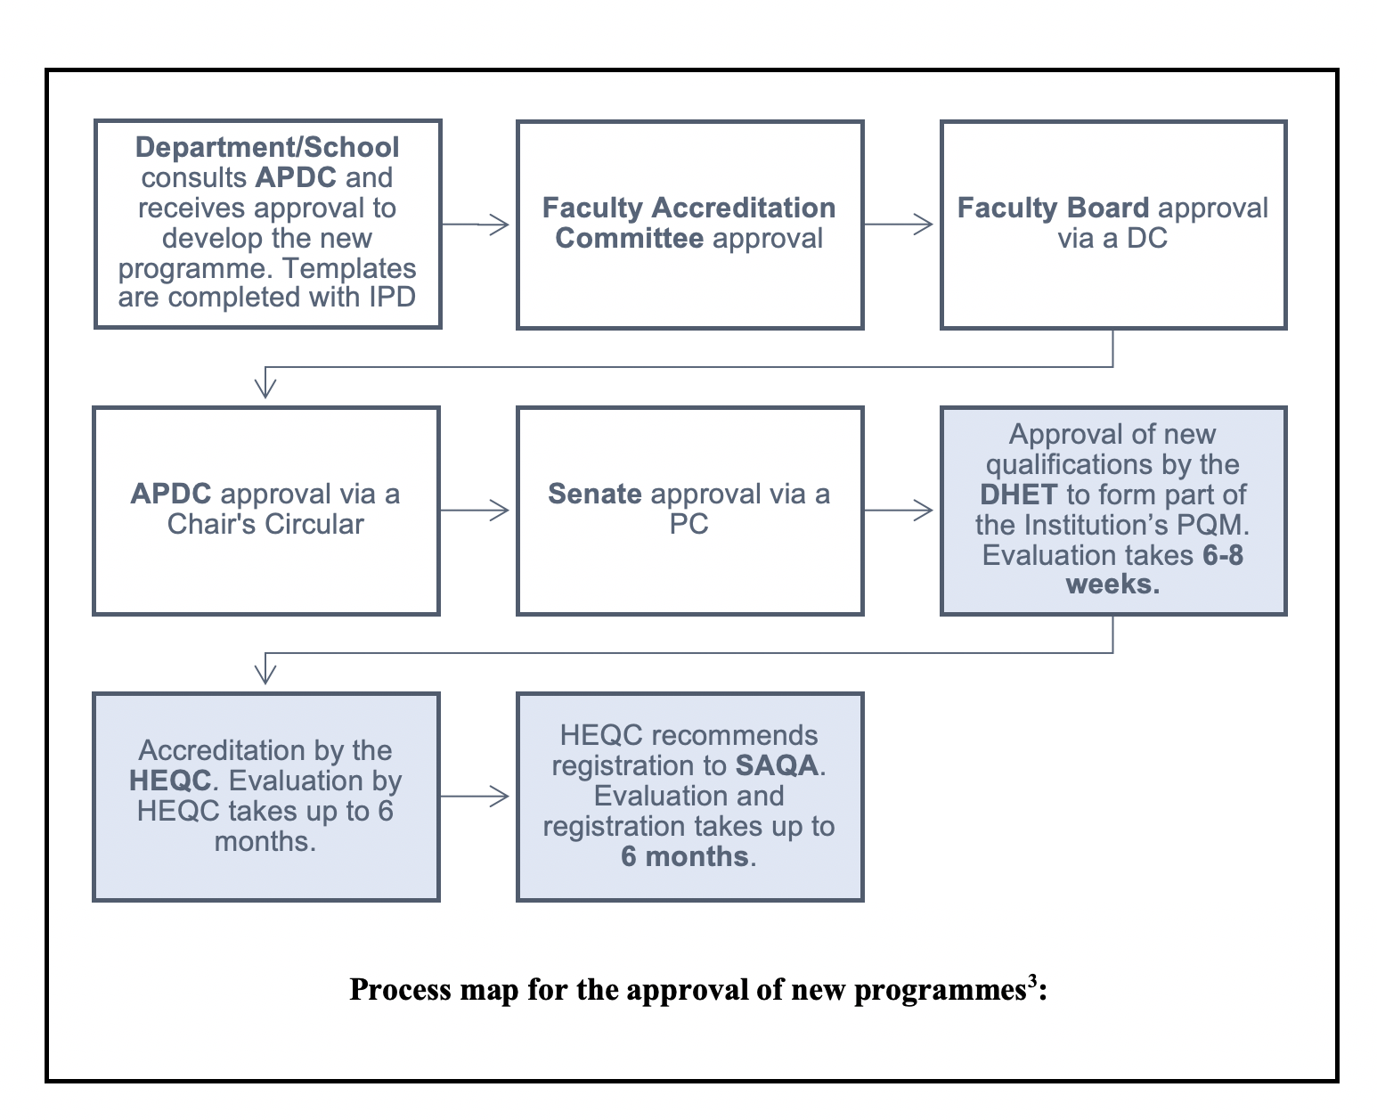

:

Section 1 – New Programme Details
1.1 Indicate the proposing Department and Faculty | Click here to enter text.
1.2 Is this:  (a) a new qualification  (b) A new specialisation in an existing qualification? | Click here to enter text.
1.3. Full title of proposed new qualification if applicable | Click here to enter text.
1.4. Full title of proposed new specialisation in an existing qualification if applicable | Click here to enter text.
1.5 Provide the programme convenor’s name and contact details | Click here to enter text.
1. Indicate if this new programme is in contact or distance mode (new specialisations in existing qualifications are offered in the mode in which the qualification was accredited) | Click here to enter text.

SECTION 2 – Purpose, Rationale and Admission

  - What is the purpose (what types of knowledge and skills does it intended to develop) of the proposed new qualification?

Click here to enter text.

  - Provide a rationale for the introduction of this new programme. Your rationale should include a response to the following:
- How will the programme meet professional, national, regional, labour market, knowledge and other sociocultural needs and widen access to higher education?
- What is the current demand for such a programme?
- Refer to any research/survey that has been conducted to investigate the demand for the new programme (evidence may be attached as an appendix).
- Who is the typical target audience and what is the duration of the new programme?
- What are the students’ learning and career pathways opportunities after completion?
- What qualification can students articulate to after completion (including to other qualifications already registered on the NQF or currently in development)?
- Can completed credits in the qualification be used towards other existing qualifications?
- Does the programme already exist at any other higher education institution(s) in South Africa? Please provide a list of these if so, and compare the new proposed programme to these.

Click here to enter text.

  - Discuss why the new programme should be introduced at UCT. You should include a response to the following:
- How does the programme relate to the Mission and the strategic direction of the University?
- If this proposed programme is a new Doctoral Degree (Professional), Advanced Diploma, Diploma (240 credit), Advanced Certificate or Higher Certificate indicate why UCT should be offering this new qualification.
- Do similar programmes and courses already exist at UCT? If yes, indicate whether the convenors of these other programmes and courses have been consulted.
- Is there cross-faculty/ interdepartmental collaboration that is required in the new programme?
- If this is a new qualification, do you perceive the introduction of future new specialisations/collaborations with other departments at UCT in the new qualification?
- Management of student enrolments with staff resourcing is important for the sustainability of new programmes. Will this new programme replace an existing specialisation or qualification on offer at UCT, and will any existing courses be closed due to the introduction of the new programme?
- How many students does the programme intend enrolling in the first three years of implementation? If this is an existing qualification, please provide the current planned numbers for the enrolment planning period.
- How will the new programme grow student numbers/ will it redirect students from an existing offering/ offer students an alternative to an existing programme?

Click here to enter text.

  - What are the proposed admission requirements of the new programme. You should include a response to the following:
- What qualification(s) / NQF level facilitates access to this proposed new programme, and does UCT offer the admitting qualification or some of the courses that facilitate access?
- If this is an existing specialisation please indicate how the proposed admission requirements differ from the existing qualification.
- Will you make use of RPL for alternative access or advanced standing?
- Will you make use of diagnostic testing for placement or curriculum design?
- Are applicants requires to demonstrate a minimum level of work experience?

Click here to enter text.

SECTION 3 –Overview of curriculum

3.1 Briefly indicate how the proposed courses will contribute towards the intended outcomes of the programme.

Click here to enter text.

SECTION 4 – TEACHING AND LEARNING STRATEGY
4.1. Briefly describe the teaching methods and use of technology mediated pedagogies. As UCT is a contact institution, should this programme be fully online or proposed as distance mode, this response must demonstrate assurance that the programme is able to appropriately develop the exit outcomes in students at a distance.

Click here to enter text.

4.2. Reflect on whether any of the Teaching and Learning findings of the last departmental review are applicable to the introduction of this new programme.

Click here to enter text.

SECTION 5– RESOURCES AND FEASIBILITY
5.1 Besides subsidy, what funding sources are available for the programme, and if the new programme is an Advanced Diploma or Higher Certificate indicate what student funding options are available.

Click here to enter text.

5.2. Do you anticipate that new staff will be required for the implementation of the new programme, taking into account planned enrolments (consider both teaching and supervision requirements)? If new staff will be required, ensure that you include reference as to how they will be funded, in your business plan.

Click here to enter text.

APPROVAL
Programme Convenor:
Head of Department:

References:
Purposes of qualification types in Higher Education including UCT examples:
Doctoral Degree | The doctorate provides training for an academic career. It requires a candidate to undertake research at the most advanced academic levels culminating in the submission, assessment and acceptance of a thesis. However, candidates may also present peer-reviewed academic articles and papers, and, in certain fields, creative work such as artefacts, compositions, public performances and public exhibitions in partial fulfilment of the research requirements. Coursework may be required as preparation or value addition to the research, but does not contribute to the credit value of the qualification. The defining characteristic of this qualification is that the candidate is required to demonstrate high level research capability and to make a significant and original academic contribution at the frontiers of a discipline or field. The work must be of a quality to satisfy peer review and merit publication. | Doctor of Philosophy
Doctoral Degree (Professional) | The professional Doctorate provides education and training for a career in the professions and/or industry and is designed around the development of high level performance and innovation in a professional context. Candidates are required to undertake a combination of coursework and advanced research leading to the submission, assessment and acceptance of a research component comprising an original thesis or another form or research that is commensurate with the nature of the discipline or field and the specific area of enquiry. The research component should comprise at least 60% of the degree. Professional Doctorates may also include appropriate forms of work-integrated learning. The defining characteristic of this qualification is that in addition to the demonstration of high level research capability it requires the ability to integrate theory with practice through the application of theoretical knowledge to highly complex problems in a wide range of professional contexts. | None
Master’s Degree | The primary purpose of a general Master’s Degree is to educate and train researchers who can contribute to the development of knowledge at an advanced level.  There are two variants of the general Master’s Degree: A research Master’s Degree by dissertation, or a research Master’s Degree by coursework and dissertation. Both variants must include a significant research component in the form of a discrete research project.  The requirements for the successful completion of a general Master’s Degree are as follows:  • Master’s Degree by dissertation: A single advanced research project, culminating in the production and acceptance of a dissertation or other forms of research as indicated below.  • Master’s Degree by coursework and mini-dissertation: A coursework programme requiring a high level of theoretical engagement and intellectual independence, and in some cases demonstration of the ability to relate knowledge to a range of contexts for professional practice. In addition, this variant of a general Master’s degree must contain a research project comprising a minimum of 60 credits at level 9. | Master of Philosophy  Master of Arts
Master’s Degree (Professional) | The primary purposes of a professional Master’s Degree are to educate and train graduates who can contribute to the development of knowledge at an advanced level such that they are prepared for advanced and specialised professional employment. In some cases, a professional Master’s degree may be designed in consultation with a professional body or fulfil all or part of the requirements for professional registration or recognition, and may include appropriate forms of work-integrated learning. The requirements for the successful completion of the professional Master’s Degree are as follows:  Successful completion of a coursework programme requiring a high level of theoretical engagement and intellectual independence as well as demonstration of the ability to relate knowledge to the resolution of complex problems in appropriate areas of professional practice. In addition, a professional Master’s degree must include an independent study component that comprises at least a quarter of the total credits, which must be at NQF level 9, consisting of either a single research or technical project or a series of smaller projects demonstrating innovation or professional expertise. | Master of Business Administration  Master of Geotechnical Engineering  Master of Laws in Commercial Law
Bachelor Honours Degree | The Bachelor Honours Degree is a postgraduate specialisation qualification, characterised by the fact that it prepares students for research-based postgraduate study. This qualification typically follows a Bachelor’s Degree, and serves to consolidate and deepen the student’s expertise in a particular discipline, and to develop research capacity in the methodology and techniques of that discipline. This qualification demands a high level of theoretical engagement and intellectual independence. | Bachelor of Sciences Honours
Postgraduate Diploma | The primary purpose of the qualification is to enable working professionals to undertake advanced reflection and development by means of a systematic survey of current thinking, practice and research methods in an area of specialisation. This qualification demands a high level of theoretical engagement and intellectual independence, as well as the ability to relate knowledge to a range of contexts in order to undertake professional or highly- skilled work. | Postgraduate Diploma in Accounting
Bachelor’s Degree | There are two types of Bachelor’s Degrees, namely general and professionally-oriented Bachelor’s Degrees. Both types of degree may be structured as a 360-credit qualification with an exit at level 7 or as a 480-credit qualification with an exit at level 8 on the National Qualifications Framework. (It is also possible to structure a 480-credit Bachelor’s degree with an exit at NQF level 7). The 480-credit Bachelor’s Degree at NQF level 8 has both a higher volume of learning and a greater cognitive demand than the 360-credit degree at Level 7 and should prepare students to be able to undertake Master’s level study by providing them with research capacity in the methodology and research techniques of the discipline.  The primary purpose of both the general and the professional Bachelor’s Degree is to provide a well- rounded, broad education that equips graduates with the knowledge base, theory and methodology of disciplines and fields of study, and to enable them to demonstrate initiative and responsibility in an academic or professional context. Both the 360 and 480-credit Bachelor’s Degrees may require students to undertake research in a manner that is appropriate to the discipline or field of study in order to prepare them for postgraduate study.  The general Bachelor’s Degree emphasises general principles and theory as preparation for entry into general employment or for a postgraduate progamme.The professional Bachelor’s Degree prepares students for professional training, post-graduate studies or professional practice in a wide range of careers. | Bachelor of Arts  Bachelor of Business Science  Bachelor of Science in Engineering in Chemical Engineering
Advanced Diploma | This qualification has a number of different purposes, depending on a student’s circumstances and the nature of the programme. It may provide entry-level vocational or professional preparation or specialisation for Bachelor’s Degree graduates or diplomates by offering an intensive, focused and applied specialisation which meets the requirements of a specific niche in the labour market. For example a BSc graduate might register for a PGCE in order to become a science teacher. Programmes offering this qualification are therefore particularly suitable for continuing professional development through the inculcation of a deep and systematic understanding of current thinking, practice, theory and methodology in an area of specialisation.  This qualification may also be designed to prepare students for postgraduate study through the deepening of their knowledge and understanding of theories, methodologies and practices in specific academic disciplines and fields, as well as the development of their ability to formulate, undertake and resolve more complex theoretical and | Advanced Diploma in Accounting  Postgraduate Certificate in Foundation Phase Teaching  Advanced Diploma in Cosmetic Formulation Science
Diploma | This qualification primarily has a vocational orientation, which includes professional, vocational, or industry specific knowledge that provides a sound understanding of general theoretical principles as well as a combination of general and specific procedures and their application. The purpose of the Diploma is to develop graduates who can demonstrate focused knowledge and skills in a particular field. Typically they will have gained experience in applying such knowledge and skills in a workplace context. | Diploma in Theatre and Performance
Advanced Certificate | This qualification is primarily vocational or industry-oriented. It emphasises selected general principles together with more specific procedures and their application and/or technology transfer. The qualification provides students with a sound knowledge base in a particular field or discipline and the ability to apply their knowledge and skills to particular career or professional contexts, while equipping them to undertake more specialised and intensive learning. Advanced Certificate programmes typically include a work- integrated learning (WIL) component. | Advanced Certificate in Foundation Phase Teaching
Higher Certificate | This is an entry-level higher education qualification. The qualification is primarily vocational, with a strong industry-oriented focus. The qualification also serves to provide students with the basic introductory knowledge, cognitive and conceptual tools and practical techniques for higher education studies in their chosen field of study. It emphasises selected general principles together with more specific procedures and their application. This qualification signifies that the student has attained a basic level The Higher Certificate typically includes a simulated work experience or work-integrated learning (WIL) component." | Higher Certificate in Adult and Community Education and Training

Support for completion of this template is provided by the Academic Planning and Quality Assurance Unit
A new programme is a new specialisation that is introduced into a qualification that UCT is already accredited to offer, or a new qualification that will require external accreditation and registration on the NQF.
Shaded areas refer to stages required for new qualifications only
Questions specifically for new qualifications are highlighted.

