READ AND WRITE DOWNLOADING INSTRUCTIONS
- Go to UCT ICTS Downloads page
- https://ictsdownloads.uct.ac.za/Downloads/Forms/Browse%20Downloads.aspx
- Log in with your Staff or Student Number
- Go to Windows; Applications; Read and Write
- Download the Read and Write zip file (depending on the speed of your internet connection this could approximately 45 minutes to 2 hrs)
- Follow these instructions
Once Read and Write has download onto your computer, unzip the file. ie extract the zip file to a folder.
Depending on which folder you unzipped the files to you will have a Read&Write directory within that folder. In this document we unzipped the file to the RW directory.
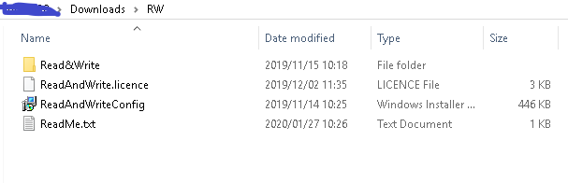1.From the Read&Write subdirectory directory run the Setup.msi (Go into the folder and look for Setup.msi ) - Windows Installer file of 4246 KB.. Accept the license agreement and continue.
This will install the Read & Write software.
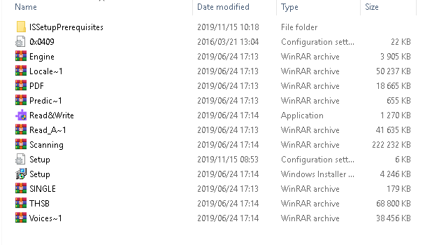
After R&W has been installed go to step 2.
2.Install ReadAndWriteConfig.
From the ReadAndWrite root directory run ReadAndWriteConfig.msi
This will set the product code and allow R&W to be used without the need to log in.

3.Once installed, there will be a R&W icon on the desktop
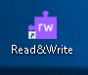
Start Read & Write
After starting Read & Write, close Read & Write. You do this by clicking the X in the top right hand corner.

4.Copy the license file for R&W from the Read&Write root folder to the following folder on your computer. (see file below marked LICENCE file as Type.. 3KB)
C:\Users\USERNAME\AppData\Roaming\Texthelp\ReadAndWrite\12
USERNAME would be your login user name.
Overwrite the existing license file. (you can type the pathway above after clicking on the C drive)
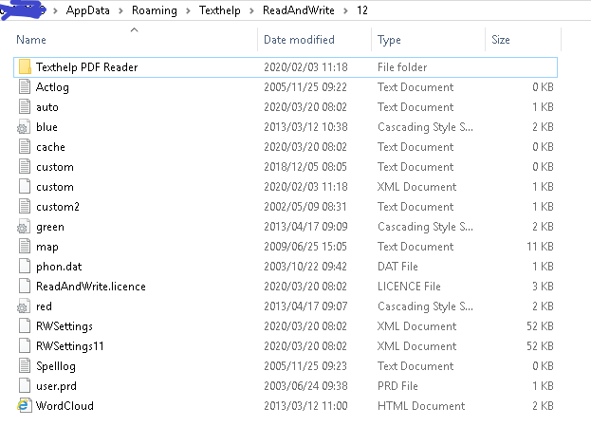
5.You will now be able to use Read & Write.
If you are not able to find the AppData folder, go to Folder options and select show
See next page
Hidden files, folder and driver as below. 