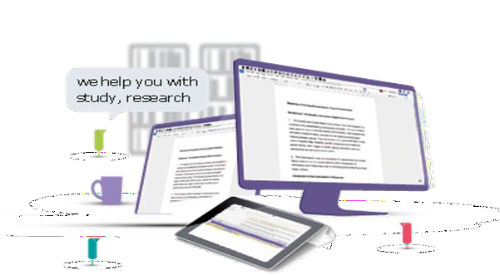

**Software helping every student understand, learn & express themselves**

# Universities worldwide are using Read&Write to improve student engagement and academic outcomes in all subjects and at all levels. All will benefit from the software including students and staff with dyslexia and other Specific Learning Disabilities

UCT’s Office for Inclusivity and Change Disability Service has purchased the latest version of the Read&Write. The software is available for free download from the ICTS downloads page and will cover all students and staff on campus and at home.

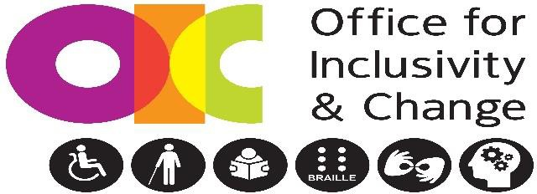

what is Read&Write?

Read&Write is a software toolbar with the literacy support features needed to provide a personalised learning experience which helps every student meet their full potential. Read&Write is great for all subjects and content: websites, Word ﬁles, PDFs, Google docs and more. The software is simple to install, it is easy for students to use independently.

who does it help?

Read&Write oﬀers support through the research tools, which can highlight and collect text for study and automatically create a bibliography. Other speciﬁc support includes:

Gives **students with Specific Learning disabilities** support to understand their course content as well as their peers. They can build vocabulary lists and use the Picture Dictionary to visualise and comprehend key words.

Helps students **express themselves** with increased ﬂuency and conﬁdence. Tools such as Word Prediction and Spell Check allow them to express their thoughts quickly and accurately. Screen Masking acts as a focus

 **Text to Speech** gives students **access to audio** that assists comprehension. The computer reader is immediately available and the audio makes all documents more accessible and inclusive for students with **dyslexia and other literacy challenge.** Audio Maker, Talk and Type, PDF Reader and the **Creation of MP3** from text files are popular features

***To Download***: Go to UCT ICTS downloads page

Windows/Applications/download Read and Write zip file/open ReadMe.txt for instructions.

Contact the Disability Service for more information [disabilityservice@uct.ac.za](mailto:disabilityservice@uct.ac.za)