Email Signature Banner Tutorial

How to load a new banner
Please click here for a brief tutorial.

How to add the UTM link :
Windows
- Copy the UTM link provided
- Click on the email signature banner
- Click on the globe as indicated by the red circle below
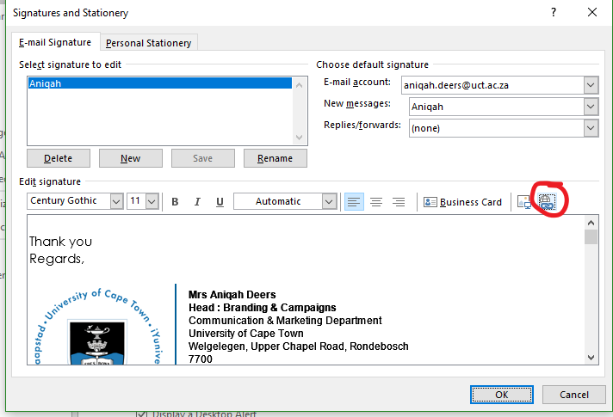
- Paste the link into the address bar

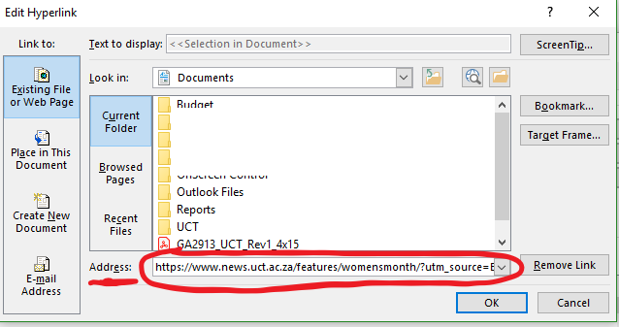

MAC
    - From the Signatures tab, select the account with the signature you want to edit in the left column of the screen.
    - Select the signature from the middle column. Drag the image you want to the signature screen.
    - Select Edit > Add Link from the menu bar, or use the keyboard shortcut Command + K.

